Heart Disease Risk Prediction

An End-to-End MLOps Pipeline

1. Introduction:
Heart disease remains one of the leading causes of mortality worldwide, making early risk prediction critical for timely medical intervention. Machine learning techniques have shown promise in assisting clinicians by identifying patients at high risk based on clinical and demographic features. However, building a machine learning model alone is insufficient for real-world adoption; the entire lifecycle from data ingestion to deployment and monitoring must be robust, reproducible, and automated.
This project presents an end-to-end MLOps pipeline for predicting the presence of heart disease using the Heart Disease UCI Dataset. The objective is to design, implement, and deploy a scalable and production-aligned machine learning system using modern MLOps practices. The pipeline covers data acquisition, exploratory data analysis, feature engineering, model training and evaluation, experiment tracking, CI/CD automation, containerization, Kubernetes deployment, and basic monitoring.
The solution leverages MLflow for experiment tracking, GitHub Actions for CI/CD automation, FastAPI for model serving, Docker for containerization, and Kubernetes (Minikube) for deployment. An optional Streamlit-based UI is included as a demonstration interface for end users.

2. Dataset Description:
The project uses the Heart Disease UCI Dataset, obtained from the UCI Machine Learning Repository. The dataset consists of clinical attributes commonly used in cardiology, including:
- Age
- Sex
- Chest pain type
- Resting blood pressure
- Serum cholesterol
- Fasting blood sugar
- Resting electrocardiographic results
- Maximum heart rate achieved
- Exercise-induced angina
- ST depression
- Slope of the peak exercise ST segment
- Number of major vessels
- Thalassemia status
The target variable is binary, indicating the presence (1) or absence (0) of heart disease. The dataset was cleaned by handling missing values and transforming the original multi-class target into a binary label suitable for classification.

3. Exploratory Data Analysis (EDA):
Exploratory Data Analysis was performed to understand the structure, quality, and statistical properties of the dataset before model development. The EDA process included:
- Identification and removal of missing or invalid records.
- Analysis of the class distribution to assess potential imbalance.
- Visualization of feature distributions using histograms.
- Examination of correlations between numerical features and the target variable using a correlation heatmap.
These analyses provided insights into feature relevance and relationships, helping guide feature engineering decisions. The EDA results confirmed that multiple features exhibit meaningful correlations with heart disease presence, justifying the use of supervised classification models.
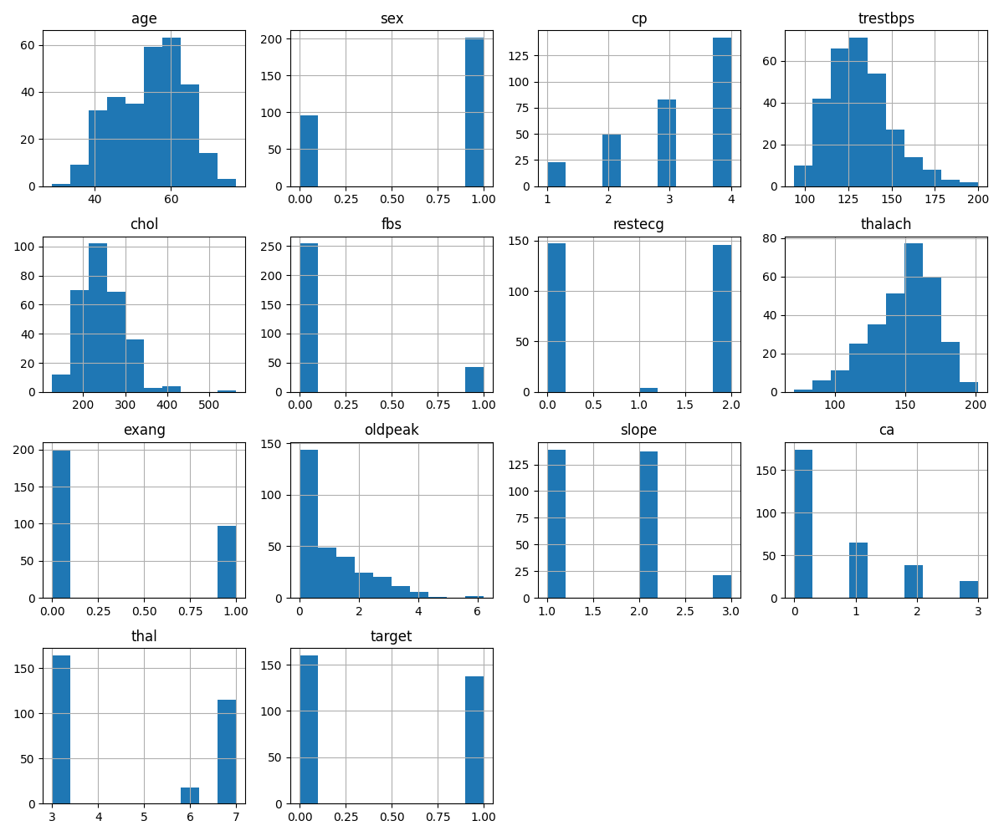

4. Feature Engineering and Preprocessing
Feature engineering was implemented using a unified preprocessing pipeline to ensure consistency across training and inference. The following steps were applied:
- Numerical features were scaled to standardize value ranges.
- Categorical features were encoded appropriately.
- A ColumnTransformer-based preprocessing pipeline was constructed to apply transformations in a structured and reusable manner.
By encapsulating preprocessing within the pipeline, the same transformations are guaranteed during model training, evaluation, and inference, reducing the risk of training–serving skew.

5. Model Development and Evaluation:
Two classification models were developed and evaluated:
- Logistic Regression
Selected as a baseline model due to its simplicity, interpretability, and suitability for binary classification tasks.
- Random Forest Classifier
Chosen to capture non-linear relationships and feature interactions that may not be well modeled by linear approaches.
The dataset was split into training and test sets using stratified sampling to preserve class distribution. Model performance was evaluated using the following metrics:
- Accuracy
- Precision
- Recall
- ROC-AUC
Both models were trained independently using the same preprocessing pipeline to ensure fair comparison. Based on evaluation results, the Random Forest model demonstrated superior ROC-AUC performance and was selected for deployment.

6. Experiment Tracking with MLflow
MLflow was integrated to track experiments, metrics, and trained model artifacts throughout the training process. For each training run, MLflow logs:
- Model parameters
- Evaluation metrics (accuracy, precision, recall, ROC-AUC)
- Serialized preprocessing and model pipeline
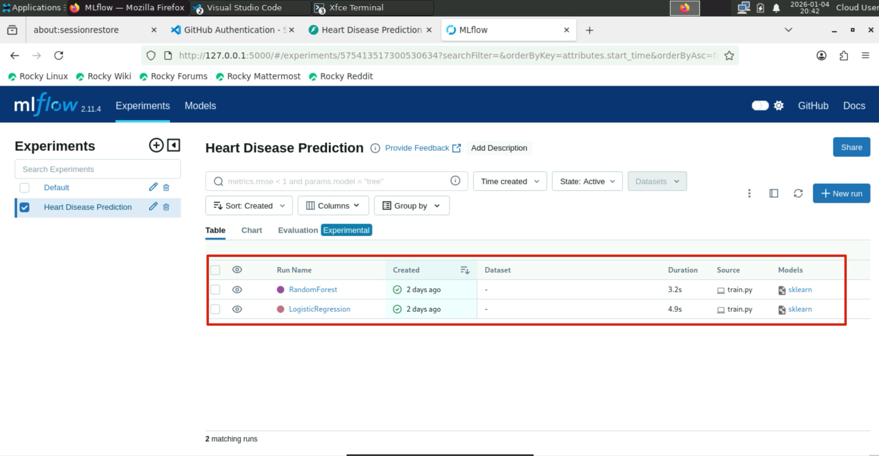
Each model run is stored as a separate MLflow run, enabling straightforward comparison between candidate models. MLflow’s experiment tracking ensures reproducibility, traceability of model versions, and transparency in the model selection process.

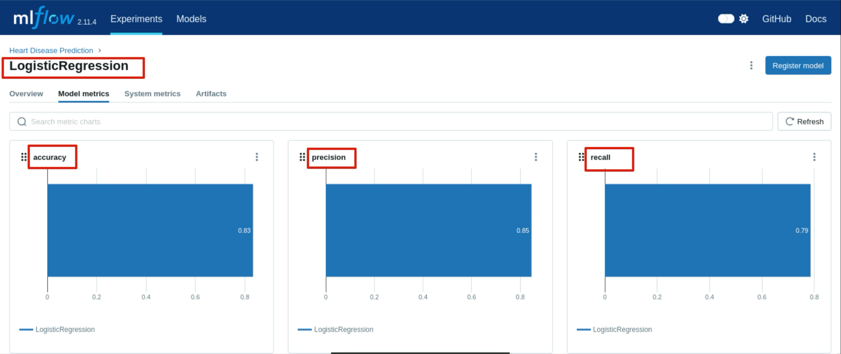

7. CI/CD Pipeline Automation (≈ 1 page)
A Continuous Integration pipeline was implemented using GitHub Actions to automate quality checks and model training. The pipeline is triggered on code pushes and pull requests and performs the following steps:
- Code checkout
- Dependency installation
- Code linting using flake8
- Unit testing using pytest
- Data preparation and EDA execution
- Model training with MLflow logging
- Artifact upload (MLflow runs and plots)
The pipeline is configured to fail on linting or test errors, ensuring code quality and reliability before training. Successful runs produce reproducible artifacts that can be used for deployment.
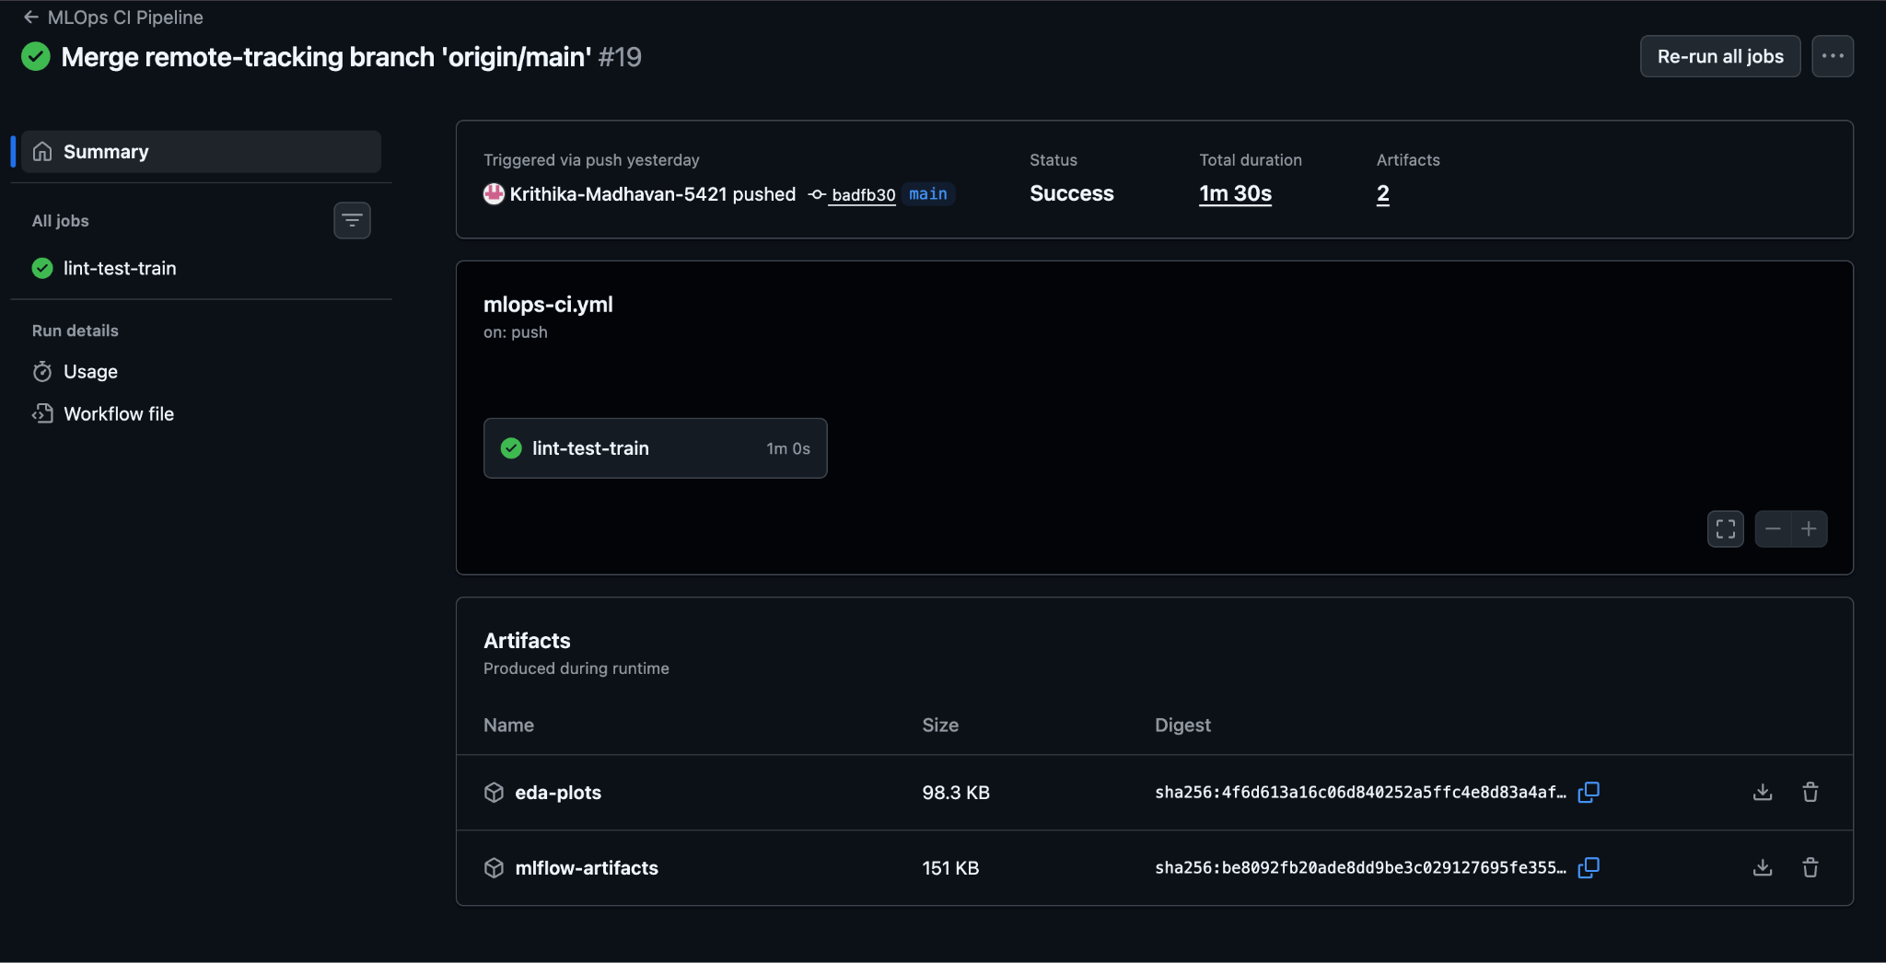

8. Model Serving and Containerization
The selected model is served through a FastAPI-based REST API, exposing a /predict endpoint that accepts JSON input and returns predictions with confidence scores. The API uses the trained MLflow model and preprocessing pipeline to perform inference.
The inference service is containerized using Docker, enabling isolated and consistent execution across environments. The Docker image includes all dependencies required to serve predictions reliably.

9. Kubernetes Deployment and Monitoring
The Dockerized inference service was deployed to a local Kubernetes cluster using Minikube. Deployment manifests define the application pod and expose the service via a NodePort, allowing local access.
Deployment verification included:
- Checking pod and service status
- Accessing Swagger UI for API documentation
- Sending prediction requests to the deployed service
Basic monitoring was implemented using:
- Application-level request logging
- Latency measurement per request
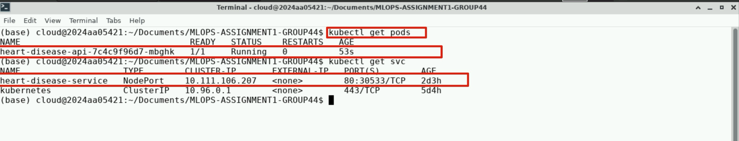
- Kubernetes pod logs for runtime visibility

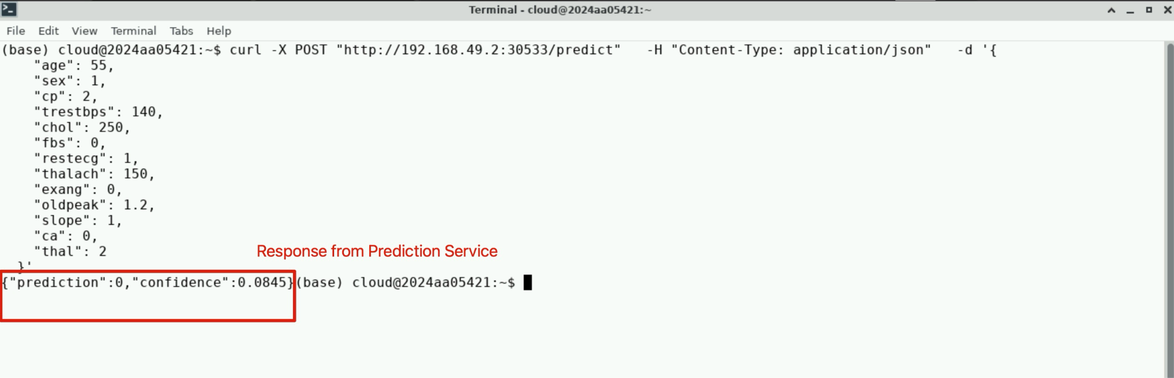

10. Streamlit Demonstration Interface:
An optional Streamlit-based user interface was implemented as a demonstration layer. The UI allows users to input patient details and invokes the deployed FastAPI /predict endpoint to display predictions and confidence scores. Streamlit does not perform inference locally and acts purely as a client to the deployed service.
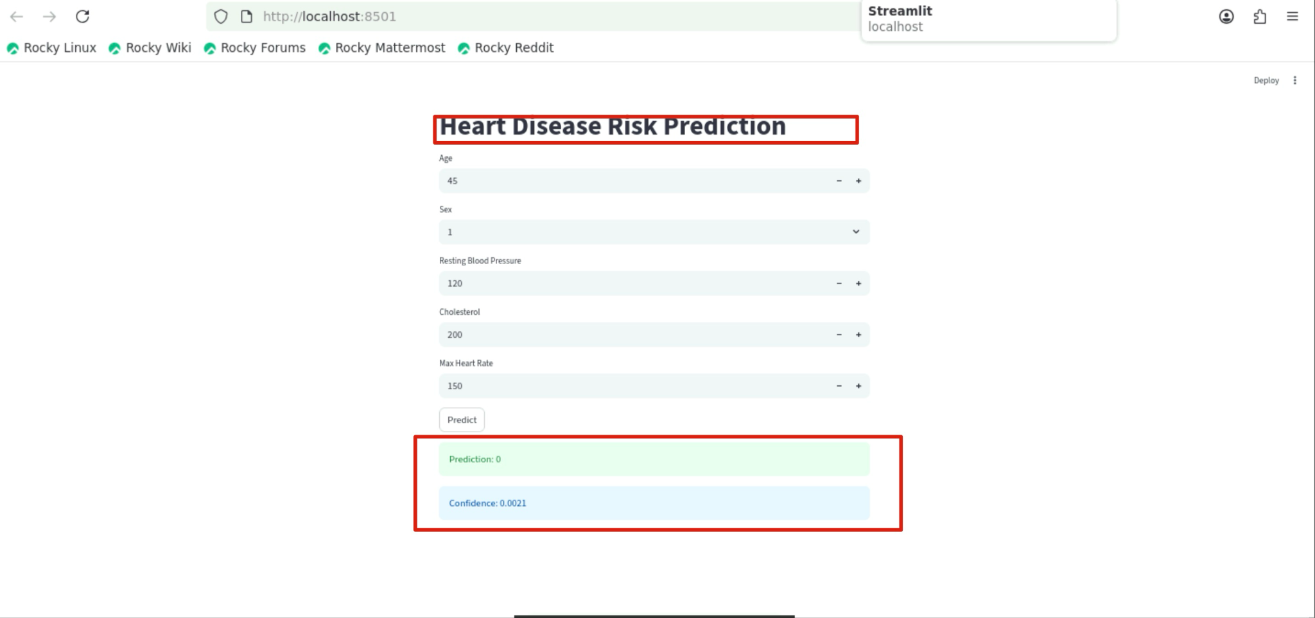

11.Conclusion:
In conclusion, this project demonstrates a complete, production-aligned MLOps workflow encompassing data preparation, model development, experiment tracking, CI/CD automation, containerized deployment, and monitoring. The system emphasizes reproducibility, scalability, and operational readiness, closely mirroring real-world machine learning deployments.

